**Monitoring Tools**

Grafana

[[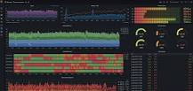](https://www.google.com/search?rlz=1C1FKPE_enIN969IN969&sxsrf=ALiCzsYowJKMTf6oOfG83Tya7tIwCOSQMw:1653709210132&q=What+is+Grafana+used+for?&tbm=isch&source=iu&ictx=1&vet=1&fir=l12hUZIIlVAwVM%252Cz82aWkRxXapNTM%252C_&usg=AI4_-kQghnWnbmOTqP6Y2huqSjszvGIQkQ&sa=X&ved=2ahUKEwi89p_wooH4AhXIR2wGHbdJCFQQ9QF6BAgZEAE#imgrc=l12hUZIIlVAwVM)](https://www.google.com/search?rlz=1C1FKPE_enIN969IN969&sxsrf=ALiCzsYowJKMTf6oOfG83Tya7tIwCOSQMw:1653709210132&q=What+is+Grafana+used+for?&tbm=isch&source=iu&ictx=1&vet=1&fir=l12hUZIIlVAwVM%252Cz82aWkRxXapNTM%252C_&usg=AI4_-kQghnWnbmOTqP6Y2huqSjszvGIQkQ&sa=X&ved=2ahUKEwi89p_wooH4AhXIR2wGHbdJCFQQ9QF6BAgZEAE" \l "imgrc=l12hUZIIlVAwVM)

Grafana is a multi-platform open source analytics and interactive visualization web application. It allows you to query, visualize, alert on, and understand your metrics no matter where they are stored.

Grafana has been installed by using the bash script and Infra has been created by using the terraform

The user interface of the grafana has been like below image

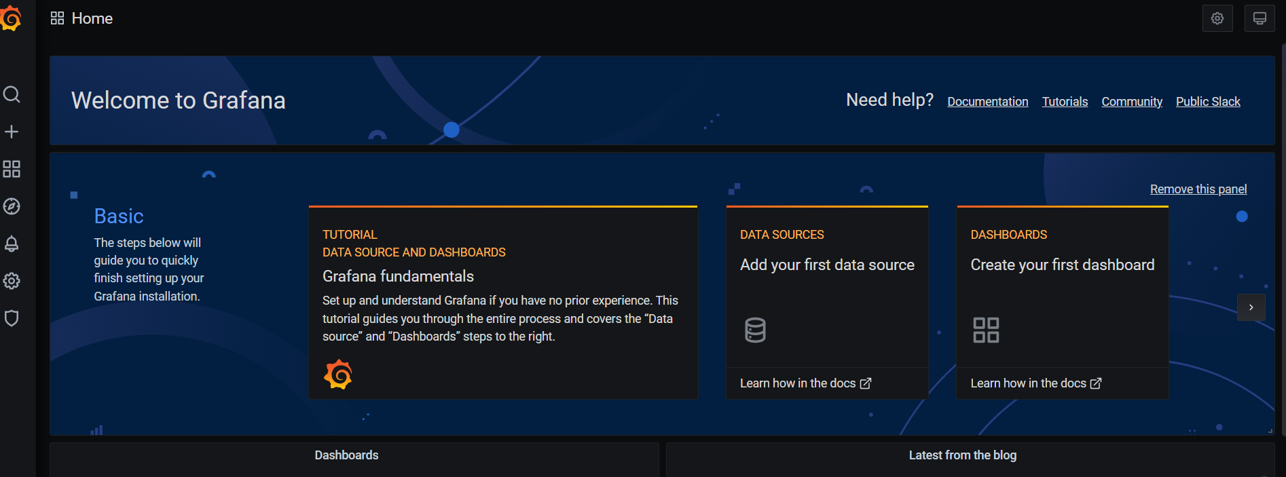

In the Grafan I had created the some users and gave the permissions for them.

**CREATE USERS**

1. On the sidebar, click the **Server Admin** (shield) icon.
2. In the Users tab, click **New user**.
3. In **Name**, enter the name of the user.
4. In **E-mail**, enter the email of the user.
5. In **Username**, enter the username that the user will use to log in.
6. In **Password**, enter a password. The user can change their password once they log in.
7. Click **Create** to create the user account.

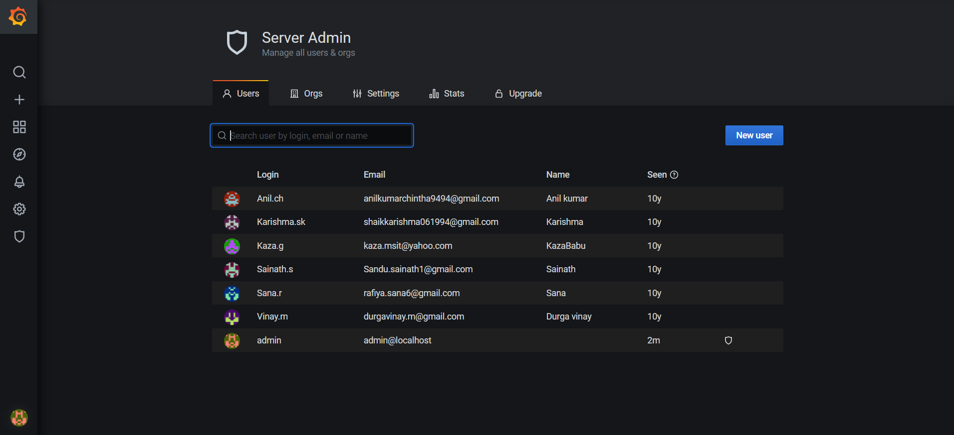

**ASSIGN THE USERS TO TEAM:**

Instead of granting permissions to individual users, teams let you grant permissions to a group of users.

Teams are useful when onboarding new colleagues. If you add a user to a team, they get access to all resources assigned to that team.

**Create a Team**

1. In the sidebar, hover your mouse over the **Configuration** (gear) icon and then click **Teams**.
2. Click **New team**.
3. In **Name**, enter the name of the team: either *Marketing* or *Engineering*. You do not need to enter an email.
4. Click **Create**.

**Add a User to the team**

1. Click **Add member**.
2. In the **Add team member** box, select the user you want to add to the team. Refer to the table above for team assignments.
3. Click **Add to teams**

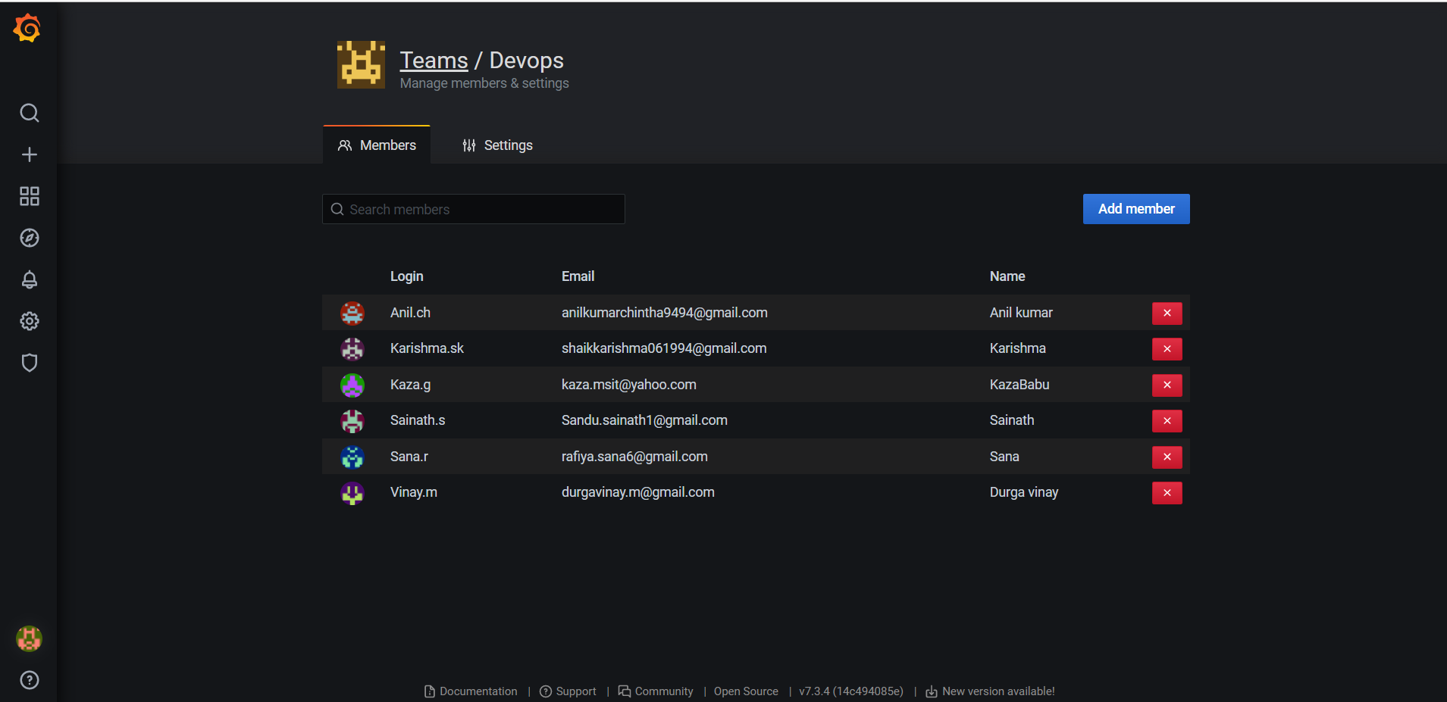

**Prometheus**

[[](https://www.google.com/search?rlz=1C1FKPE_enIN969IN969&sxsrf=ALiCzsaSjobLTr2tBuCPLuDEalnPkS46tg:1653709033891&q=What+is+Prometheus+used+for?&tbm=isch&source=iu&ictx=1&vet=1&fir=0PtzVy6wFNOYzM%252CXuu8nzgkc_KooM%252C_&usg=AI4_-kQN93W2dgZqG_6lk7eYY9WMmqqRAw&sa=X&ved=2ahUKEwjXnZucooH4AhVfTGwGHU2WDDUQ9QF6BAgYEAE#imgrc=0PtzVy6wFNOYzM)](https://www.google.com/search?rlz=1C1FKPE_enIN969IN969&sxsrf=ALiCzsaSjobLTr2tBuCPLuDEalnPkS46tg:1653709033891&q=What+is+Prometheus+used+for?&tbm=isch&source=iu&ictx=1&vet=1&fir=0PtzVy6wFNOYzM%252CXuu8nzgkc_KooM%252C_&usg=AI4_-kQN93W2dgZqG_6lk7eYY9WMmqqRAw&sa=X&ved=2ahUKEwjXnZucooH4AhVfTGwGHU2WDDUQ9QF6BAgYEAE" \l "imgrc=0PtzVy6wFNOYzM)

Prometheus is a free software application used for event monitoring and alerting. It records real-time metrics in a time series database with flexible queries and real-time alerting.

Prometheus installation has been done by using the bash scrpit

Infra has been created by the terraform

The user interface can be presented like below image

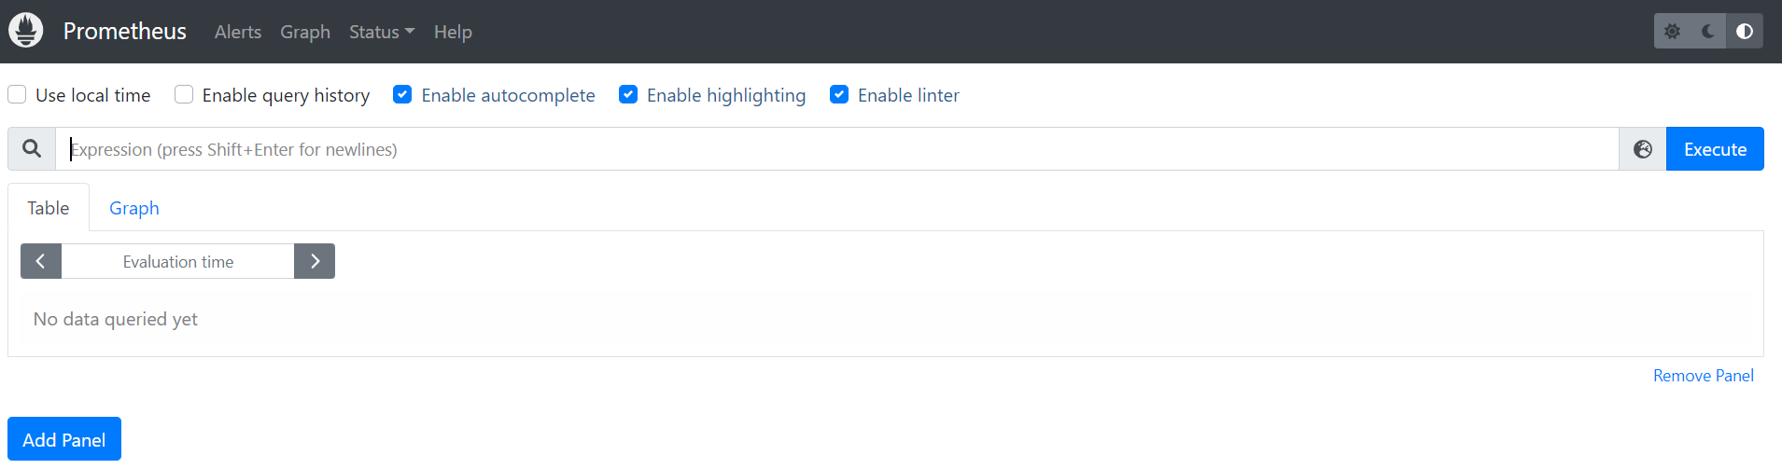

The inteegration of the Grafan and prometheus has not done

Jenkins integrate to Sonarqube

1 connect to Sonarqube

create a new project and enter name of project

after create a token for the project

2 Integrate to Sonarqube with jenkins

go to manage jenkins >>> Manage plugins >>> Available section >>> search for Sonarqube scanner >>> click on it >>> Install without restart

3 Add of the Credentials of sonar to jenkins

go to Manage jenkins >>> Manage Credentials >>> click on Jenkins >>> click on the global Credentials >>> add credentials >>> go to Kind select secret text

>>> copy the sonarqube token >>> give the Id & Description names as same

4 Add of environment of sonarqube

go to Manage jenkins >>> Configure system >>> go to Sonarqube server and click on the environment of sonarqube

add sonarqube >>> give the name and url( public ip with port 9000) >>> authentication token >>> save

( On Daily basis take ip and add in the section)

5 add of the sonarscanner plugin

Manage jenkins >>> global tool configuration go to sonarqube scanner >>> add and give the name >>> install automatically >>> save

We can create a job in the jenkins integrate the sonarqube

We can create a job for one code like maven , npm

Sonarqube code can be analysis the codes see the bugs , errors ,vulnariablity,code smells

Sonar has some sort of code can passed or failed

Code should be passed when it has limited bugs or no bugs

Code having the more bugs and more vulnariablity it has been fails .

